

**Group Meeting #2**

The meeting of TeamSix has decided at Discord at 14th March 2021.

**Attend present**

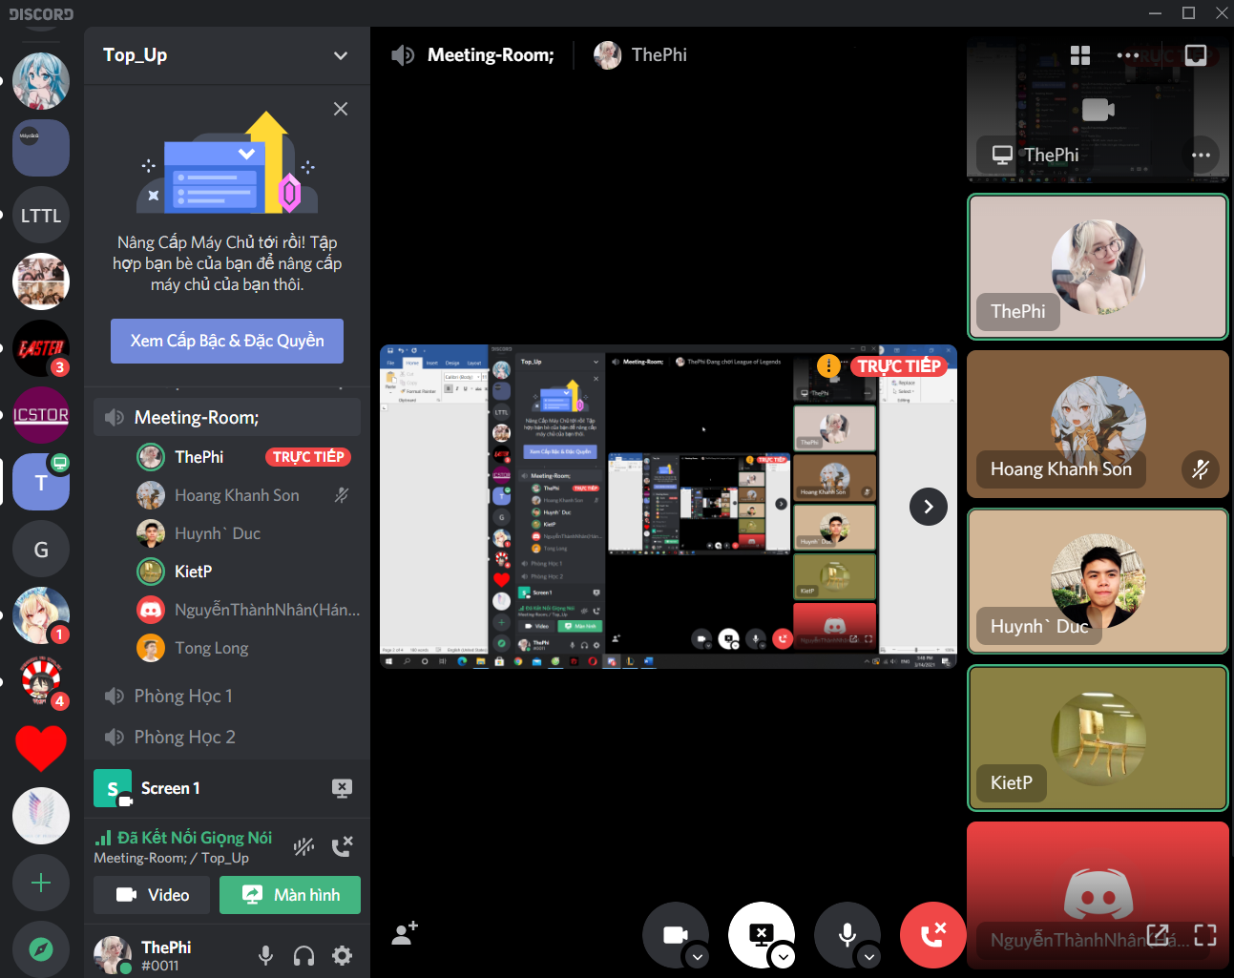

**There is 6 members in meeting:**

Pham The Phi

Hoang Khanh Son

Nguyen Hoang Nhan

Trinh Huynh Duc

Tong Dam Thang Long

Pham Tuan Kiet

**Member Not Attendance**

None.

**Report about**

Discuss each member's division of positions, division of work, prepare schedules and plan.

**Time Meeting**

An initial team discussion about the project was held on 14th March, 2021 at 15h30.

**Approve comments during the meeting**

Everyone agrees

**Unfinished Work**

Follow up project.

**Next Work**

Work will hold at the next meeting at 20th March 2021.

**Work progress**

Advantage.